
AWAIS KHALIL
Phone (P):  +92-313-4548664, +92-323-4663530
Email (E): awais489@yahoo.com Skype (S): awais489
LinkedIn (L): pk.linkedin.com/pub/awais-اويس-خليل/54/a58/1a3/
Website (W): http://awaiskhalil89.wordpress.com/
Address: House#264 E-1 Railway signal shop Lahore, PAKISTAN

Objective Statement

2+ years experience in the IT industry focusing on Software Quality Assurance, Quality Control and Data Analysis. Keeping myself in the Mobile application testing domain has enabled me to discover and learn new cutting edge testing techniques regarding the domain, enhancing my knowledge about the UTC and the hardware itself.

I consider myself a fast learner, a quick adjuster and a person who is devoted to his work by all means and it is my objective to work with an organization that can utilize me to my full potential and can create chances for me to excel in my professional field.

Present Employment
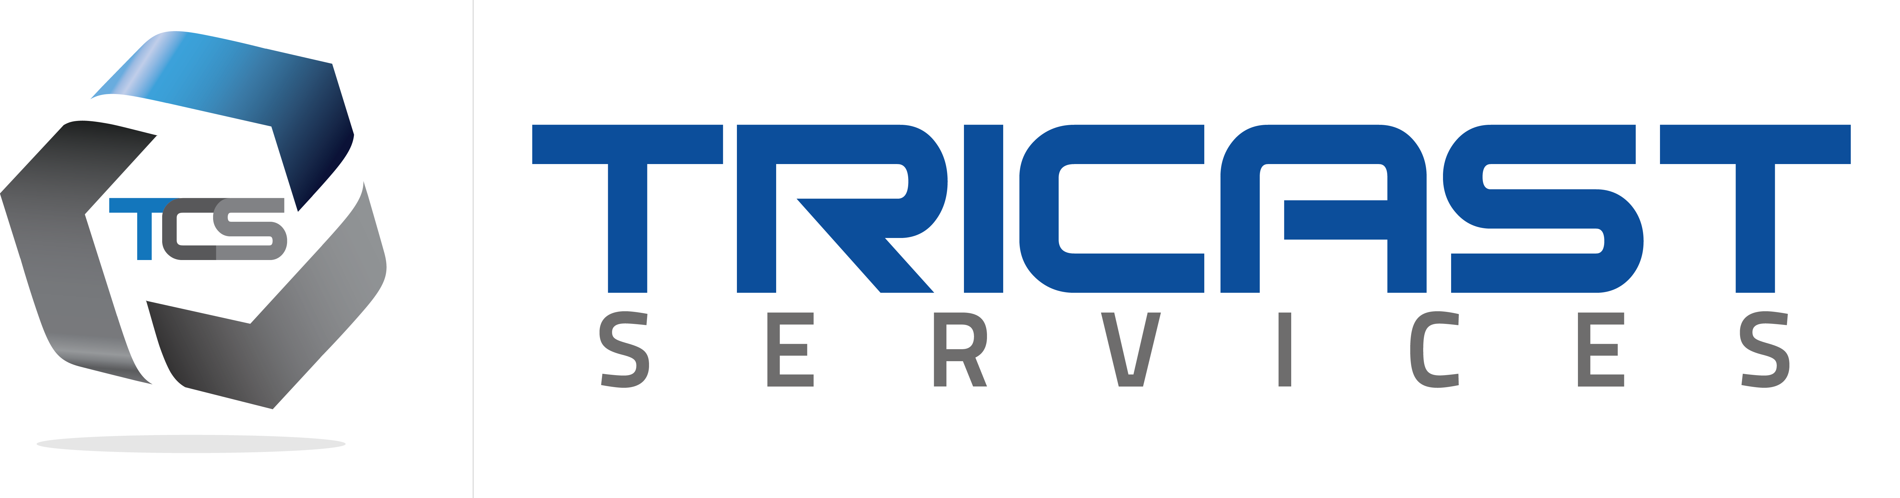
Company name: Tricast Services Pvt Ltd
Post Title: SQA Engineer
Tenure: July 2011 – Present
URL: http://www.tricastservices.com/

Brief description of duties:

- I’ve been involved in testing of J2ME/J2EE, Symbian, Meego, iOS, Android, iPAD & windows based application along with the desktop applications and website testing.
- Hands on experience in SDLC, STLC and Testing (using Manual Testing and Automated Testing Tools involving complex client/server and web based applications)
- Design and execute testing scenario and test cases
- Prepare Checklist and release version change documents before finalizing build to client
- Give feedback and recommendation to developers/TL about technical feasibility
- Monitor the live server and handle run time issues of web and mobile app
- Mentor junior QA resources and give appropriate training’s to them
- I’ve also gone through experience of testing Nokia mobile app with international languages including Arabic, Persian, and English
- Log, track and manage issues by using bug management tool (Bugzilla)
Projects

I have worked on the following projects during my stay at Tricast Services:
- CricketCompanion V4.0 Mobile Clients (Best mobile app at P@sha 2012 - 13)
- CricketCompanion Web and desktop application

Cricket Companion is a FREE mobile application that provides latest cricket scores on all mobile. If you are a Cricket lover then what you are waiting for? Download now and enjoy latest cricket matches, latest cricket news. http://www.cricketcompanion.com/
http://m.crick.cc/

- DreamX1 fantasy game for Nokia ovi
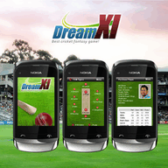
Cricket Companion Dream XI - Fantasy Cricket Mobile Application has a fantastic graphical user interface (GUI) that is fun to play. Think you know Cricket and have got what it take? Download Dream XI, create your team and prove it to the world. All you have to do is select a team of international Cricket Players and get points based on their life performance. http://store.ovi.com/content/319423/

- Ludo Game for Nokia ovi (English, Farsi)


Although, Ludo has its roots in ancient India but it is played in many countries under various names (with different variations). App was built for Nokia devices and Meego devices and Multi-languages has been used i.e. Persian and English. And provide you help on each screen for user ease.
Users now have the option of playing this popular board game on their mobile phones, either as a single player game against the system or with friends and family using the multi player option on a network using Bluetooth or internet connectivity. http://www.theludo.com/ or download http://ludo.crick.cc/

- Carrom Game for Nokia ovi (English, Arabic & Persian)

There is no blinking to the fact that Carrom has been our childhood’s most popular indoor game. Now you get the opportunity to play this popular game directly on your phone. You can play against the system in a single player mode or with the multiplayer option using Bluetooth, internet and Wi-Fi. In every screen, there is a help option, which can be used, in case of any confusion. http://www.thecarrom.com or download from here http://carrom.crick.cc/

- Nokia Lumia Quiz app (Windows mobile)

- Nestle Trade Tracker (Client) & Report handling (Server)


Trade Tracker is a complete Enterprise level project in which continuous integration is required in order to be updated. This app is built for Android OS devices (Samsung and Huwaei) in which merchandiser visits the shops around the different cities of our country and collect stock taking of their (86) products. Benefits of this app are to increase the productivity as well as to increase sales. And reporting end is automatically done through CMS (Admin Panel) and generates daily stock taking and manager level reports.

- pepsi Trade Tracker (Client) & Report handling (Server)


Trade Tracker is a complete Enterprise level project in which continuous integration is required in order to be updated. This app is built for Android OS devices (Samsung and Huwaei) in which merchandiser visits the shops around the different cities of our country and collect stock taking. Benefits of this app are to increase the productivity as well as to increase sales. And reporting end is automatically done through CMS (Admin Panel) and generates daily stock taking and manager level reports.

- Address Finder Mobile app


The app will guide User from the Source location to the destination (a picture of the destination can be taken by tagging the location). The app is built for Android OS. The app is also build for Nestle client to provide sales agent/delivery man assistance relating to searching their specified ON or OFF route.

- RadioScore App and Admin panel (Web interface)
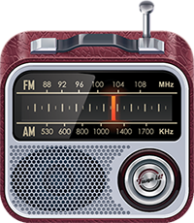
RadioScore is an android based mobile app in which user listened his desired channel and all the data will be record in xml file. Basically, it is built for checking user interest on a channel. I did exhaustive testing and data integrity validation.

- Unilever Activation portal (Website)

Unilever activation portal is a web based interface where brand manager initiate an activity and invites different marketing/advertising agencies. Agencies submit their proposals and activity cost required for approval to brand managers.

- Engro Trade Tracker

Technical Skills

Proficient in the following tools:
Bugzilla, SeeTestAutomation, Selenium IDE 2.4, jMeter, MS Visio, Altova XMLSpy, Link checker pro, SQLyog, winbox, Adobe photoshop CS3

Expertise

- Ability to handle multiple projects standalone and don’t get bore with repetitive tasks
- Possesses a positive, quality-oriented, reliable, and flexible attitude.
- Passion for learning new technologies and automation tools
- Ability to work under pressure in order to meet deadlines
- Working in Agile scrum methodology

Education
School/University | Subjects/Courses | Qualification | Year | Grade/ CGPA
Virtual University of Pakistan | Computer/IT, Software Engineering | BS in Computer Science | 2011 | 2.70 or 61%
Axis College of Arts & Science | Computer, Stat, Math | ICS | 2006 | C+
P.R High School | G. Science | Metric | 2004 | B

References

I am writing to recommend Mr. Awais Khalil, I used to live with him at same street and during that time I had the pleasure of having friendship, and his tremendous abilities never ceased to amaze me. I have enjoyed watching the way he has grown and excelled, so I fully understand his capabilities. Khalil is also able to work effectively with other co-workers, making him a great addition to the team. I have no doubts you will be exceptionally pleased if you hire him. If you have any questions, please feel free to contact me at the above address. Sincerely, Syed Abbas Ali Shah Business Development Manager Welding Product Division (Lincoln Electric USA) Mob: 056-7678341 Tel: 03-8572296x300 Fax: 038580329
Position: Business Development Manager at Lincoln Electric
Relation: Syed Abbas Ali Shah is colleague

